YEAR 9 SCIENCE
NATURAL + PROCESSED MATERIALS
ACID REACTIONS

Aim To observe three common acid reactions and derive general word equations for them.

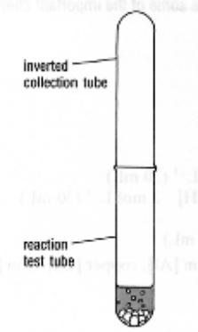
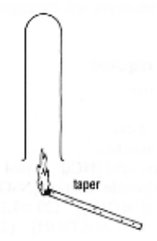
Method

Acid + Metal

• Place 2 cm of 2M HCl in a test tube.
• Place a strip of Mg ribbon in the acid and place a test tube over
the top of the reaction.
• After a minute or so, without tipping the collecting test tube, place
it near a flame from a taper.
• Write down your observations.

Acid + Base

• Place 10 drops of 2M HCl in a test tube.
• Add 2 drops of universal indicator and note its colour.
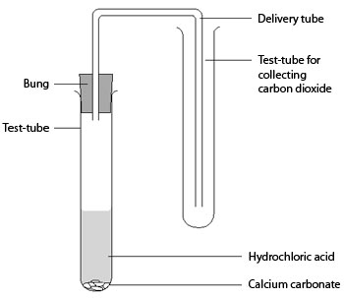
• Add 2 M NaOH one drop at a time and count how many drops are needed
to turn the colour green (neutral).
• Repeat the procedure with phenolphthalein indicator, counting the drops until
a colour change occurs.

Acid + Carbonate

• Place 2 cm of limewater in a test tube.
• Place 2 cm of 2M HCl in another test tube. Add some solid calcium carbonate
(CaCO₃) to the test tube and place a cork (with delivery tube attached) in it.
• Bubble the gas produced through the limewater and write down your observations.

Observations

REACTION | OBSERVATIONS
Acid + metal
Acid + base | Universal:
Acid + base | Phenolphthalein:
Acid + carbonate

Discussion

Conclusion

